Sprint 3 - Agility Design Document

April 22, 2020

Jason Lyons, Chloe Joyce, and Reese Griffin

# **1.** **Executive Summary**

## **1.1** **Project Overview**

In this project, our group will program a robot, using block code from the app Sphero Edu, to circumnavigate itself in an obstacle course where it will start in a square, it will encounter 3 objects which it will have to avoid, next go over a ramp, and finally knock as many pins down at the end. Our intended audience is Professor Eckert and the rest of our class.

**1.2** **Purpose and Scope of this Specification**

In scope

* Technology use

Out of Scope

* We aren’t able to test robot in the classroom

# **2.** **Product/Service Description**

## **2.1** **Product Context**

SpheroEdu can relate to other products of a similar type as the basis of the coding and algorithms given can be applied to other robotics projects as well, such as the general ideas of “turn 90 degrees” or “continue straight”. Not only this, but it can allow for students to build an understanding of robotics and what goes into programming and coding, which can help with building and designing other species of systems. The coding itself may be only fitted to the Sphero+ robot, however, and may require reworking in order to get them accustomed to other programs.

## **2.2** **User Characteristics**

Students: As students, we will be using the app Sphero Edu to create and produce this sprint. This program will allow us to create a code that will make the robot being used travel in an obstacle course starting in a square, avoiding 3 objects, going over a ramp, and finally knocking down as many pins as possible.

**2.3** **Assumptions**

The operating system is assumed to be available, the robot is assumed to be available, technology for the app being used is assumed to be available.

## **2.4** **Constraints**

Describe any items that will constrain the design options

* No access to the robot
* No access to technology
* No access to the space/area to run the program
* Not knowing exact dimensions/measurements of area being used for program

## **2.5** **Dependencies**

Dependencies that will affect the requirements:

* Must have a form of technology with bluetooth enabled to connect to the robot.
* Need a proper area to run the program (flat, large amount of space, nothing on floor).
* Must have a robot in general to run the program, Sphero+ being recommended specifically.
* Robot must be properly aligned, charged, and prepared for the run.

# **3.** **Requirements**

Requirements

1. Robot must start in a square
2. Robot must encounter the 3 object and avoid all of them
3. Robot must then go over the ramp
4. Robot must roll straight right into the pins knocking down as many as possible

## **3.1** **Functional Requirements**

|  |  |  |  |  |  |
| --- | --- | --- | --- | --- | --- |
| Req# | Requirement | Comments | Priority | Date Rvwd | SME Reviewed / Approved |
| ENDUR_01 | Start in a square | After a few tries, it is correct | 1 | 4/21 | Yes |
| ENDUR_02 | Encounter 3 objects and avoid all of them | Code was a bit harder to do, as we don’t have the robot and the figure 8 shape is hard to keep in the same positions the whole time | 2 | 4/21 | Yes |
| ENDUR_03 | Go over the ramp | Use app to steer aim to make it go smoothly to corner 2 | 3 | 4/21 | Yes |
| ENDUR_04 | Roll straight into the the pins, knocking down as many as possible | Not completely possible, as we aren’t in class | 4 | 4/21 | Yes |

## **3.2** **Security**

### **3.2.1** **Protection**

· aim not being centered

· object on floor causing robot to go a different direction

· app Sphero Edu not working correctly

· robot not being charged

. technology not being available

### **3.2.2** **Authorization and Authentication**

As for the authorization and authentication, to use Sphero Edu, you need to create a login to access the app. After making this login, you are then able to program and code with a robot that is connected via Bluetooth. Authentication can be relied heavily on sites like PubCookie. This site helps keep users on particular sites safe, keeping their information and other important things hidden from the public.

## **3.3** **Portability**

Portability of the code from the app Sphero Edu to the robot is necessary for this project to be complete.

# 

# **4.** **Requirements Confirmation/Stakeholder sign-off**

|  |  |  |
| --- | --- | --- |
| Meeting Date | Attendees (name and role) | Comments |
| 4/21 | Jason, Chloe, Reese | Confirmed all requirements |

# **5.** **System Design**

## **5.1** **Algorithm**

* Start program with robot starting in a square
* Encounter the 3 standing objects
* Avoid all objects by turning away from them
* Roll straight to go over the ramp
* Land and turn towards pins
* Roll into the pins, knocking down as many as possible

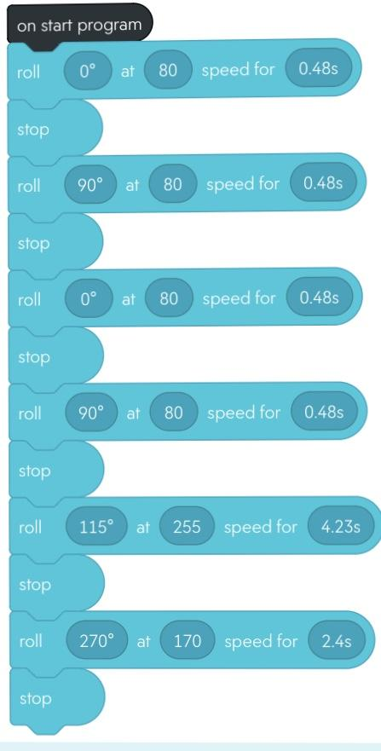

**5.2** **System Flow**

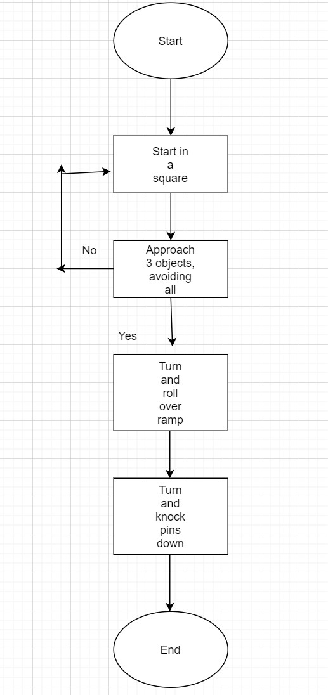

## **5.3** **Software**

The software platform that was used was Sphero Edu, and it was used to create the coding for this sprint.

## **5.4** **Hardware**

The hardware platform used to develop, test, and demonstrate this sprint was Sphero Edu. We used block coding through the app, which was connected to the robot to develop and test the algorithm.

## 

## 

## **5.5** **Test Plan**

|  |  |  |  |  |  |
| --- | --- | --- | --- | --- | --- |
| **Reason for Test Case** | **Test Date** | **Expected Output** | **Observed Output** | **Staff Name** | **Pass/Fail** |
| Starts in a square | 4/21 | Robot starts program in a square | Robot started the program in a square | Reese | Pass |
| Robot avoids 3 objects and goes over ramp | 4/21 | Robot navigates through the 3 standing objects without hitting any of them and then proceeds to jump the ramp | Robot got around all 3 objects, with a close call on one but didn’t hit it and proceeded to jump a make-shift ramp | Reese | Pass |
| Robot rolls straight knocking over pins | 4/21 | After jumping the ramp, the robot turns towards the pins and rolls into them knocking them over | Robot knocked over some, but not all. Turn might’ve been a bit too wide but can be easily fixed | Reese | Pass |

## 

## 

## 

## **5.6** **Task List/Gantt Chart**

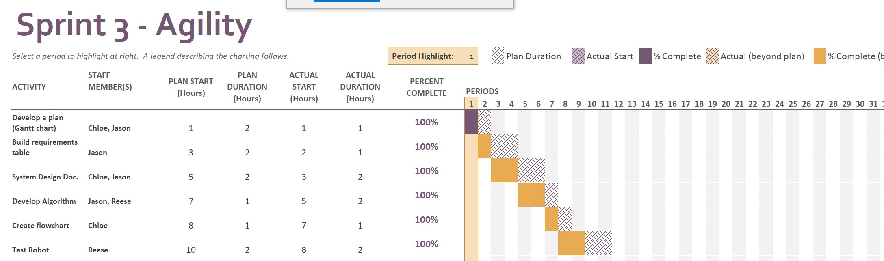

## **5.7** **Staffing Plan**

Table below depicts the roles and responsibilities of each team member.

|  |  |  |  |
| --- | --- | --- | --- |
| Name | Role | Responsibility | Reports To |
| Jason Lyons | System design document, gantt chart | Complete document fully with correct information | Everyone |
| Chloe Joyce | System design document, flowchart | Complete document fully with correct information | Everyone |
| Reese Griffin | Code | Has robot, did code and programming | Everyone |